11.5 Making salts (PartⅠ)
Name: ____________________ Class: ____________________ Due date: 12.2
1. Which acid reacts with ammonia to produce the salt ammonium sulfate? （ ）
A hydrochloric B nitric C phosphoric D sulfuric

2. Four stages for preparation of a salt from an acid and a solid metal oxide are listed.
1 Add excess solid.
2 Evaporate half the solution and leave to cool.
3 Filter to remove unwanted solid.
4 Heat the acid.
In which order should the stages be carried out? （ ）
$$\begin{aligned}&\text{A} 1→3→4→2 \\ &\text{B} 2→1→3→4 \\ &\text{C} 4→1→3→2 \\ &\text{D} 4→2→1→3\end{aligned}$$
3. Which methods are suitable for preparing both zinc sulfate and copper(II) sulfate? （ ）
1 reacting the metal oxide with warm dilute aqueous sulfuric acid
2 reacting the metal with dilute aqueous sulfuric acid
3 reacting the metal carbonate with dilute aqueous sulfuric acid
A 1,2 and 3 B 1 and 2 only C 1 and 3 only D 2 and 3 only

4. The apparatus shown is used to prepare aqueous copper(II) sulfate.
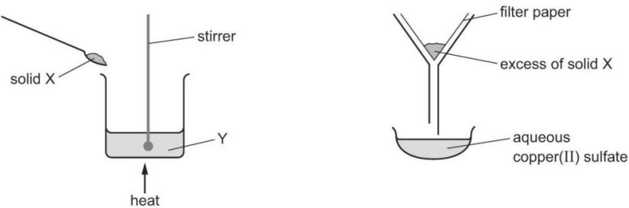
What are X and Y? （ ）
 | X | Y
A | copper | aqueous iron(II) sulfate
B | copper(II) chloride | dilute sulfuric acid
C | copper(II) oxide | dilute sulfuric acid
D | sulfur | aqueous copper(II) chloride

5. Which two compounds would react together to form insoluble salt lead(II) chloride?（ ）
 | compound | solubility in water
1 | lead(II) nitrate | yes
2 | lead(II) sulfate | no
3 | silver chloride | no
4 | sodium chloride | yes
A 1 and 3 B 1 and 4 C 2 and 3 D 2 and 4
6. Which process is not used in the preparation of an insoluble salt? （ ）
A filtration B washing C crystallisation D drying

7. A student carries out an experiment to prepare pure magnesium sulfate crystals.
The diagram shows the first stage of the preparation.
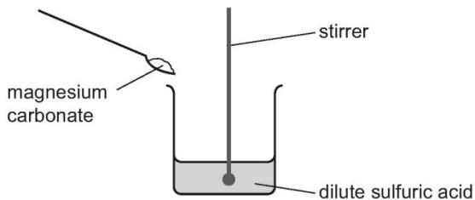
He adds magnesium carbonate until no more reacts.
Which process should he use for the next stage? （ ）
A crystallisation B evaporation C filtration D neutralisation

8. Which method is used to make the salt copper sulfate? （ ）
A dilute acid $+$ alkali
B dilute acid $+$ carbonate
C dilute acid $+$ metal
D dilute acid $+$non- metal oxide

9. A salt is produced in each of the following reactions.
P magnesium + dilute hydrochloric acid
Q zinc oxide + dilute sulfuric acid
R sodium hydroxide + dilute hydrochloric acid
S copper carbonate + dilute sulfuric acid
Which statements about the products of the reactions are correct? （ ）
1 A flammable gas is produced in reaction P.
2 Water is formed in all reactions.
3 All the salts formed are soluble in water.
A 1, 2 and 3 B 1 and 2 only C 1 and 3 only D 2 and 3 only
10. The solubility of some salts is shown
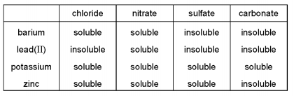
Which two aqueous solutions produce an insoluble salt when mixed together?（ ）
A barium chloride and zinc nitrate
B barium nitrate and lead(I) nitrate
C lead(II) nitrate and potassium carbonate
D potassium nitrate and zinc sulfate

